**Content**

**1. About this Document ……………………………….................... 2**

**1.1 How this Document is organized ……………………………….. 2**

**1.2 Contact Information ..……………………………………………..…. 3**

**2. Introduction ……………………………………………………………..... 4**

**2.1 Objectives …………………………………………………….……........ 4**

**3. Flow chart ……………………………….................................... 5**

**3.1 Flow chart diagram …….…………………………………..…………… 5**

**4. Sprints ………………………………………………………………..…… 6**

**5. Solution Overview …………………………………………………….. 8**

**5.1 User Interfaces ……………………………………………………….… 8**

**6. Github ……………………………………………………………………….. 9**

**1. About this Document**

This functional and integration (FIS) document will enable you to understand the proposed solution of Quiz Application

The content of the document will have a solution and its configuration details as it will be available for our client.

**1.1 How this Document is organized**

This document is organized into following chapters:

Chapter 2 - "Introduction" provides solution scope to be delivered to our Client.

Chapter 3 - "Flow chart" provides how the user is interacting with the application.

Chapter 4 - "Sprint Planning" provides how the application was developed in each sprint.

Chapter 5 - "Solution Overview" provides information on Company Lockers Pvt. Ltd.

Components and Interfaces in system.

Chapter 6 - “Open Items” provide information about the software enhancement

still to be done.

Chapter 7- “Github link” provides the information where the project is located.

**1.2 Contact Information**

Quiz Application welcomes your comments and suggestions on the quality and usefulness of this document. For any questions, comments, or suggestions on the documentation, you can contact us at the following address:

**For Contact and enquiry**

Gautam Das

Tel: +91 7980876391

**2. Introduction**

This document describes the implementation of Quiz Application and how its users can interact with the application.

Quiz Application is a Quiz portal that lets people to know and check their knowledge on the website.

**2.1 Objectives**

The objective of this document is to describe how the Quiz Application will integrate with User.

This document also provides information on end-to-end workflow so that business users can understand the features and functionalities of the Quiz Application portal.

The workflow mainly involves the following important aspects,

1. Quiz Application open with a home page that allows users to choose the language(subject) in which they want to test and check their knowledge from various options.

2. Based on the option selected in the home page, it will start the quiz with various questions and answers.

3. Once the person submits the Quiz application, they will be taken to result-and-review page where they check how many options, they choose right and check the correct answers for their wrong answers.

4. If he/she wants to attempt the Quiz again then simply they need to press the button in the bottom of result-and review page and they will again send back to home page and start the quiz from various options.

**3. Flow chart**

3.1. The objective of this session if to show how the user interacts with the flow of the Company Lockers Pvt Ltd.

**Start**

Results/Review

User answers the questions

**End**

Start Quiz

User chooses a topic

Home Page

**4. Duration of Sprints required:**

* I have divided this application in 1 sprints of 3 days. In first 1 days I made a plan to how to create the application, the next day I developed the application code for Home page, Quiz page and Result -and-Review Page and creation of json data and In the last day I tested and create the documentation of the entire application.

**5. Solution Overview**

Platform requirement

The platform used for this project is the Visual Studio Code as our code Editor

The Technologies used are Angular, json-server, TypeScript, Bootstrap, JavaScript, Html5, CSS

Below is the Home page of the application

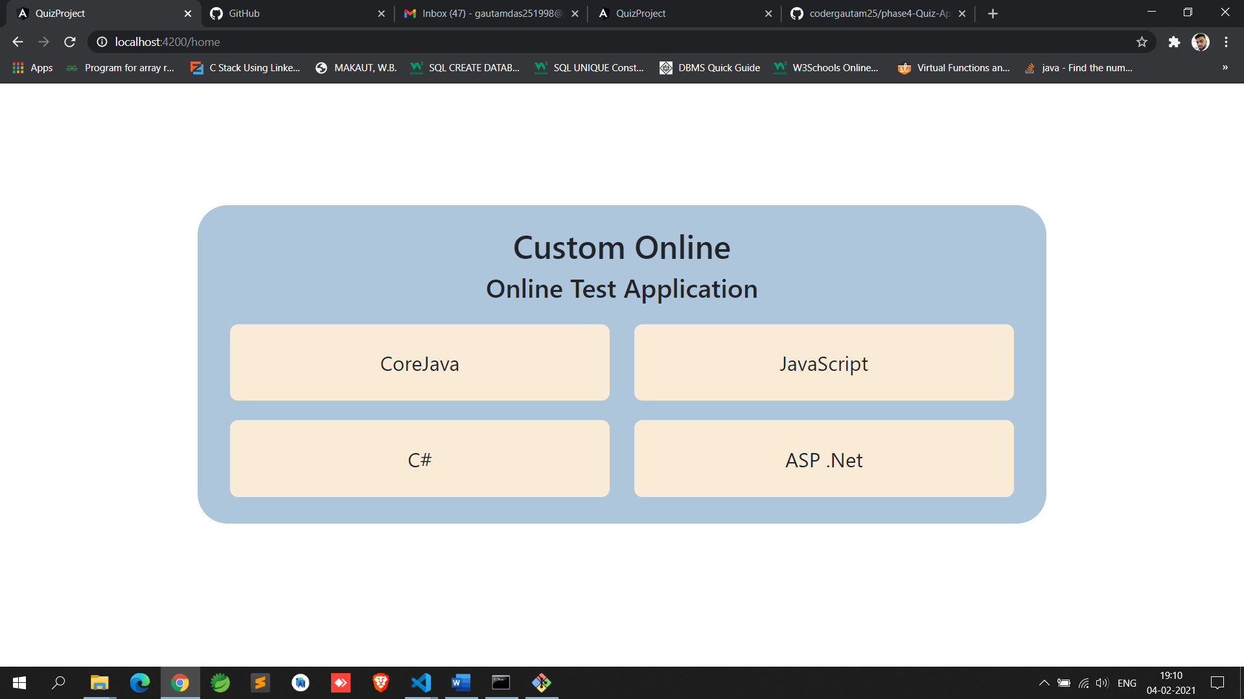

Below is the Available quiz question for the selected option

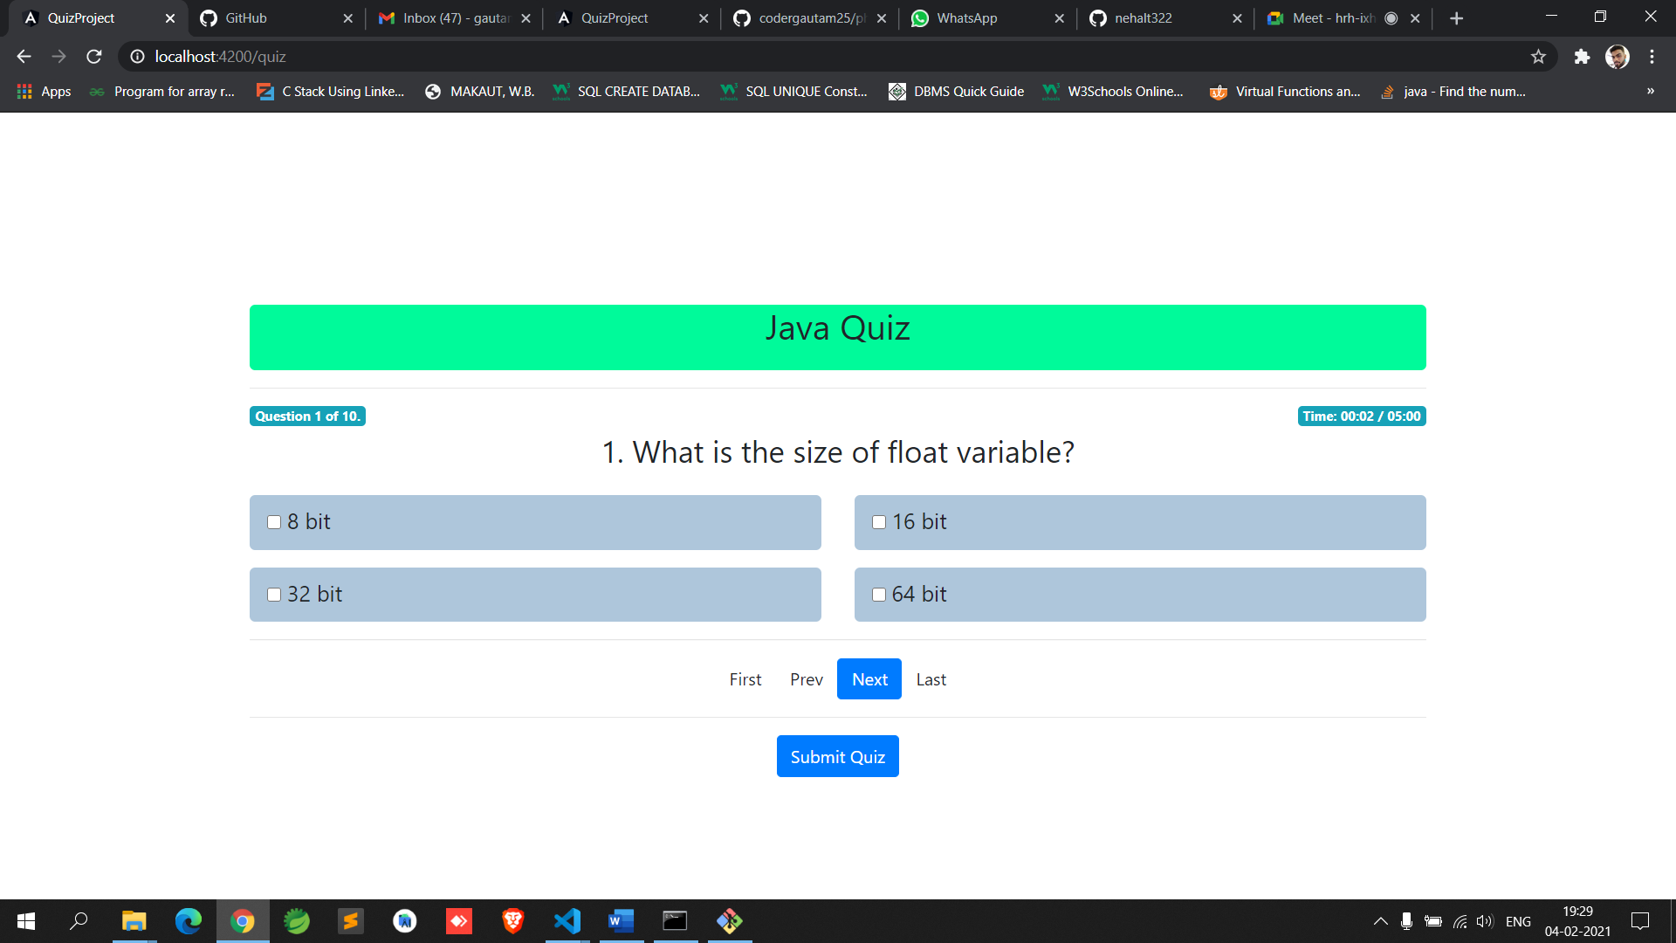

Below is the Result-and Review for the Quiz

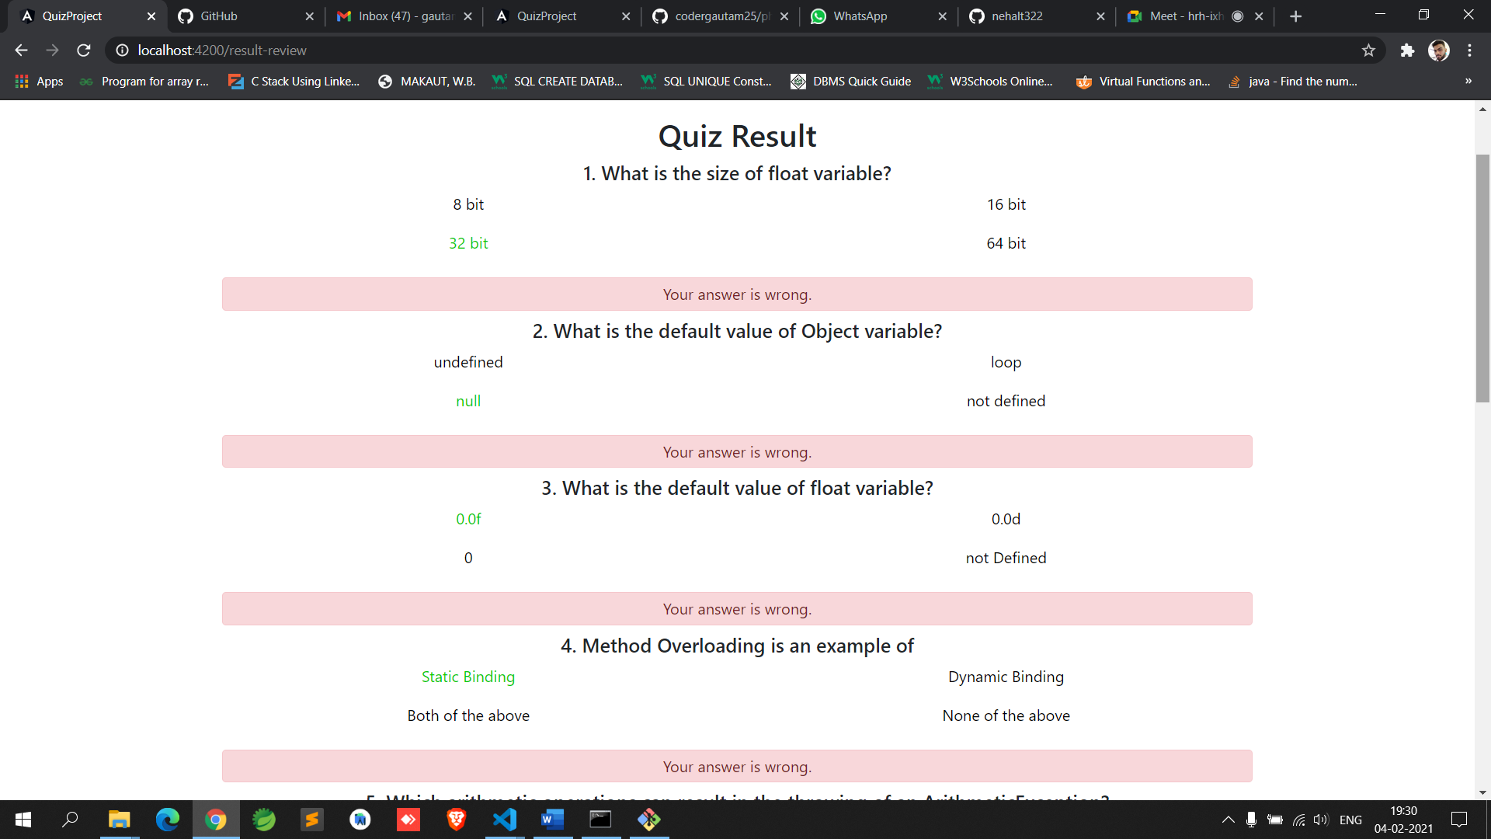

**6. GitHub Link**

**https://github.com/codergautam25/phase4-Quiz-Application.git**